1. Agenda:
   1. Going to create a Spring Boot app acting as a consumer.
2. 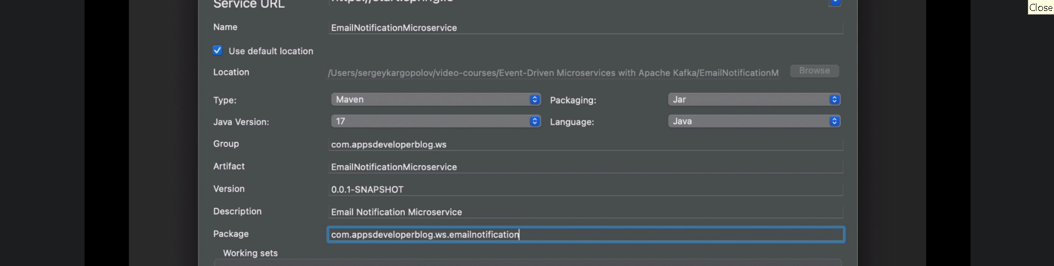
3. 